Name:-Avdhesh Kumar Sharma Class:-Btech Cse Aiml-4A

Rollno-2K21CSUNO4008 Subject:-PT1 of DBMS

1. Dependent (eno char(3), dpname varchar(20), dpdob date, dprelation varchar(20))

ENO DPNAME DPDOB DPRELATION

---------------------------------------------

e02 ab 01-MAR-65 father

e02 bc 02-AUG-80 brother

e03 dc 02-JUL-89 son

e03 bc 02-JUL-89 daughter

e05 ef 06-JAN-60 mother

e06 fg 07-JUL-50 daughter

Sol:-

create database practical;

use practical;

Create table Dependent (eno char(3), dpname varchar(20), dpdob date, dprelation varchar(20));

desc Dependent;

Insert into Dependent(ENO,DPNAME,DPDOB,DPRELATION)values('e01','ab','1965-03-01','father'),

('e02','bc','1980-08-02','brother'),

('e03','dc','1989-07-02','son'),

('e04','bcd','1989-07-02','daughter'),

('e05','ef','1960-01-06','mother'),

('e06','fg','1950-07-07','daughter');

select *

from Dependent;

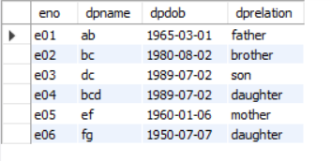

**ALTER table Dependent**

**ADD PRIMARY KEY (eno);**

**desc Dependent;**

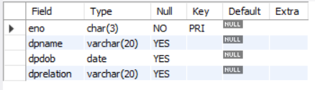

**ALTER TABLE Dependent**

**ADD CONSTRAINT c1 UNIQUE (dpname);**

**desc Dependent;**

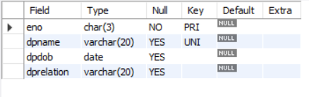

**UPDATE dependent SET dpname= 'fg1' WHERE eno = 'e03' ;**

**select * from dependent;**

